**DAILY ONLINE ACTIVITIES SUMMARY**

|  |  |  |  |  |  |  |  |  |
| --- | --- | --- | --- | --- | --- | --- | --- | --- |
| **Date:** | **21/05/2020** | | | | | **Name:** | **Lavanya D M** | |
| **Sem & Sec** | **4th & ‘A’** | | | | | **USN:** | **4AL18CS041** | |
| **Online Test Summary** | | | | | | | | |
| **Subject** | | **MES** | | | | | | |
| **Max. Marks** | | **30** | | **Score** | | | **15** | |
| **Certification Course Summary** | | | | | | | | |
| **Course** | **HTML and CSS** | | | | | | | |
| **Certificate Provider** | | | **Bitdegree** | | **Duration** | | | **2WEEK** |
| **Coding Challenges** | | | | | | | | |
| **Problem Statement:** Write a C program to implement SRTF process scheduling. Input: A set of processes with their burst time and arrival time Output: The processes scheduled based on the arrival time and a smaller burst time.  Write a C program to construct a singly linked list by removing duplicate elements in the sorted linked list Description: Take a sorted list and traverse the list. Compare the current node element with next adjacent node. If it is same then delete second element, if not retain. Finally print the resulting list. Sample output: Given list {1,2,2,3,3,3,4} Resulting list{1,2,3,4} | | | | | | | | |
| **Status:complied** | | | | | | | | |
| **Uploaded the report in Github** | | | | | **Yes** | | | |
| **If yes Repository name** | | | | | <https://github.com/lavanyamurthi/lockdown-coding/commit/e4c97b8c08191a96aabb12142c783cda67e2ec0f>  <https://github.com/lavanyamurthi/lockdown-coding/commit/cc71e0de004070799b04d32ce55709443df48be5> | | | |
| **Uploaded the report in slack** | | | | | **Yes** | | | |

Online Test Details: (Attach the snapshot and briefly write the report for the same)



Certification Course Details: (Attach the snapshot and briefly write the report for the same)



I had successfully completed the html and css course even I uploaded in gitbub here is the link <https://github.com/lavanyamurthi/lockdown-certificate/blob/master/Capture%20html%20certi.PNG>

Coding Challenges Details: (Attach the snapshot and briefly write the report for the same)

Problem1:

Write a C program to construct a singly linked list by removing duplicate elements in the sorted linked list  
Description:  
Take a sorted list and traverse the list. Compare the current node element with next adjacent node. If it is same then delete second element, if not retain. Finally print the resulting list.  
Sample output:  
Given list {1,2,2,3,3,3,4}  
Resulting list{1,2,3,4}

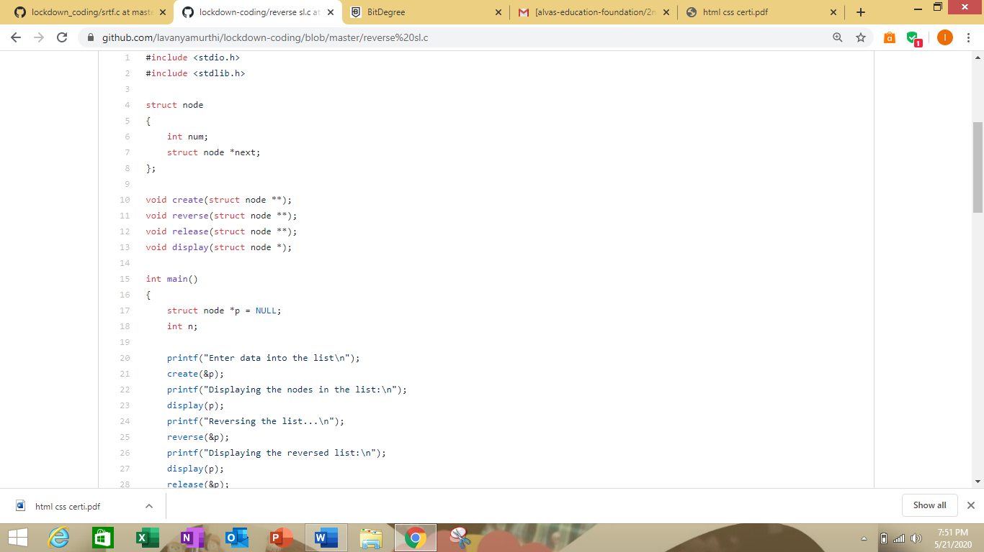

Problem2: Write a C program to implement SRTF process scheduling.  
Input: A set of processes with their burst time and arrival time  
Output: The processes scheduled based on the arrival time and a smaller burst time.

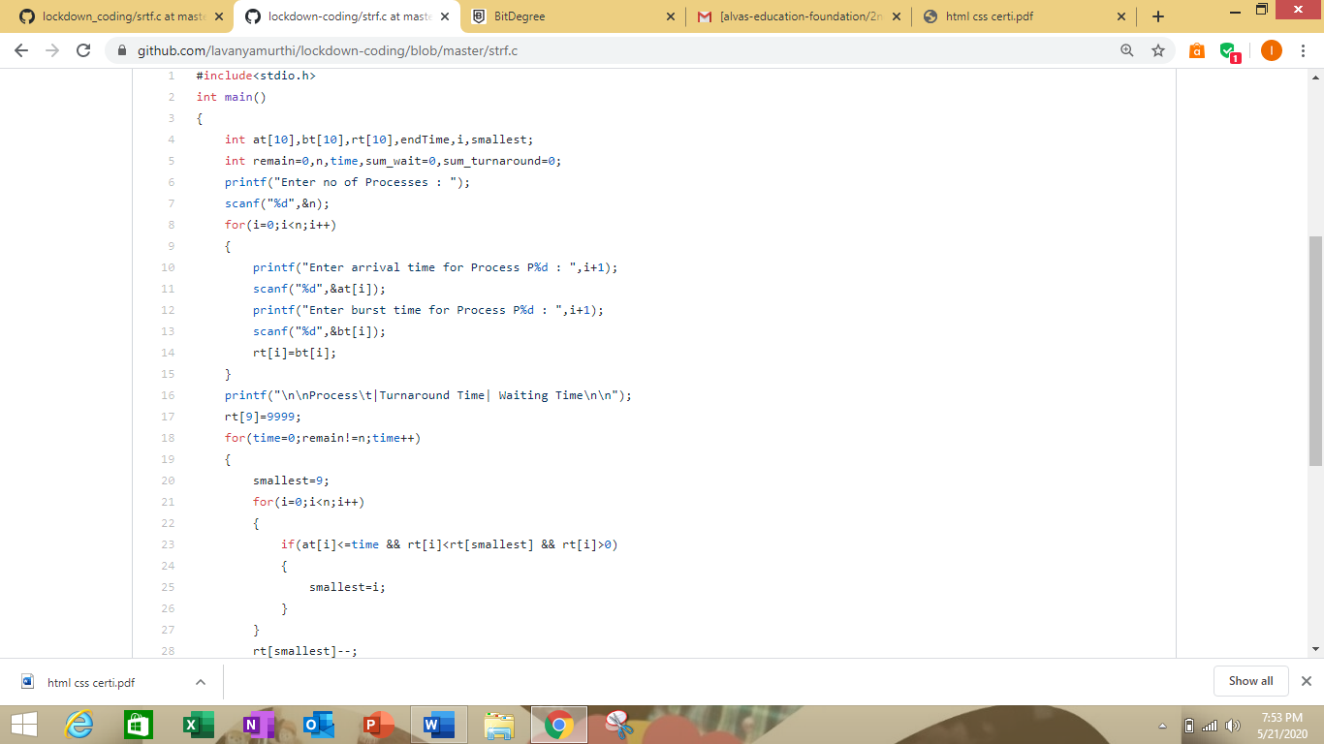

Here I provided the GitHub repository link of coded program

<https://github.com/lavanyamurthi/lockdown-coding/commit/e4c97b8c08191a96aabb12142c783cda67e2ec0f>

<https://github.com/lavanyamurthi/lockdown-coding/commit/cc71e0de004070799b04d32ce55709443df48be5>